

Handson 2

Big Data Systems

Soheil Shirvani - 3720505



Contents

Lunching Stado Parallel database 2

Steps for lunching Stado Parallel: 2

Task 1 4

1.a Create a partitioned table partab 4

1.b Insert the tuples (with given values) into partab 5

2.a Create a replicated table reptab. 6

2.b Insert the tuples (with given values) into reptab 7

Results Only: 8

Schema of your table partab (output of: show table partab) 8

Output of the query: SELECT * FROM partab 8

Schema of your table reptab (output of: show table reptab) 8

Output of the query: SELECT * FROM reptab 8

Task 2 9

Run 3 query on Stado as parallel database. 9

Query 1: 9

Query 3: 10

Query 6: 11

Run 3 query on PostgreSQL as Single database. 12

Query 1: 12

Query 3: 13

Query 6: 14

Results Only 15

Average execution time of the warm runs of Q1, Q3 and Q6 with Stado 15

Average execution time of the warm runs of Q1, Q3 and Q6 with Single DB 15

Speedup of Q1, Q3 and Q6 achieved with Stado against single instance PostgreSQL 15

# Lunching Stado Parallel database

## Steps for lunching Stado Parallel:

1. Here first we login into 4 different VMs. 1 is master VM and 3 Slave VMs. To do so we open all the VMs and login.

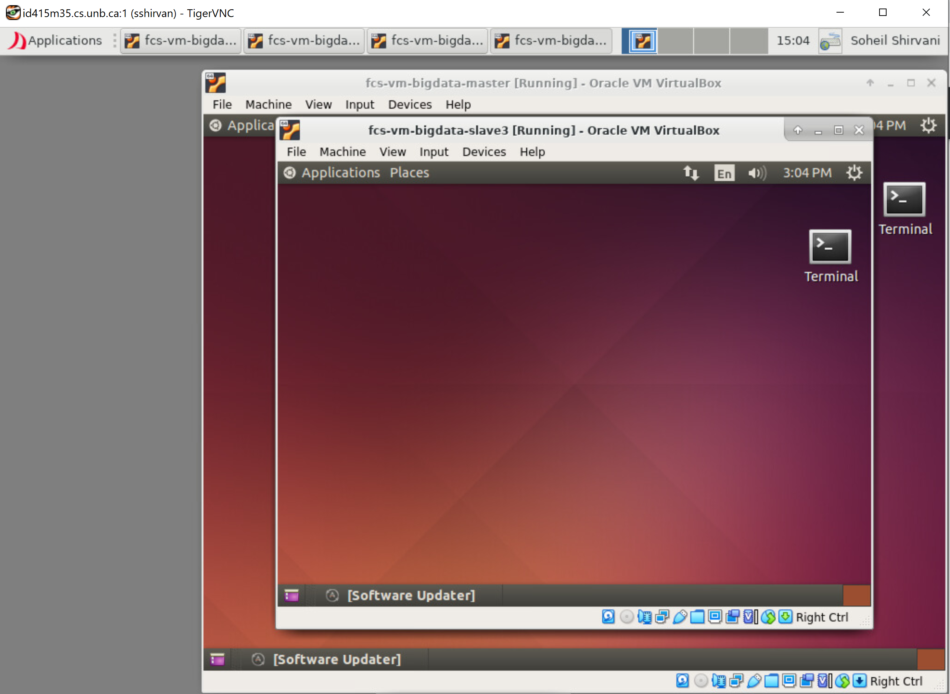

1. Start single PostgreSQL database on all the VMs. **$ pg_ctl start**

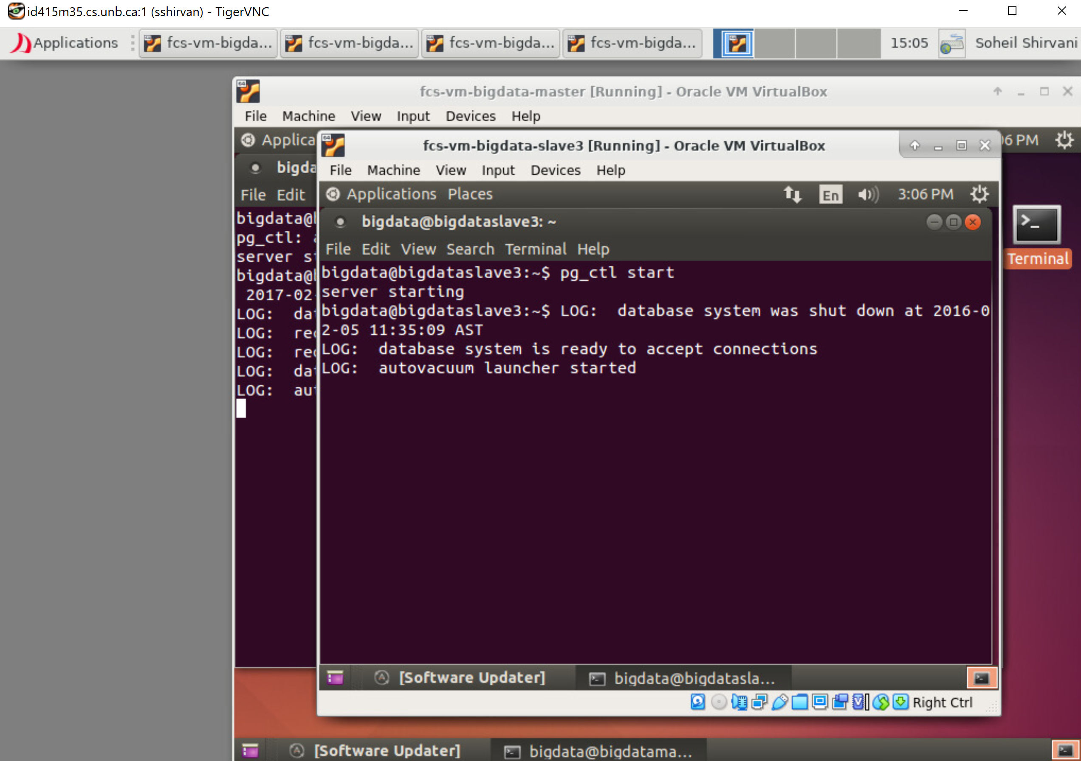

1. On master VM we will start parallel Stado database. **$** **gs-server.sh -d testdb**

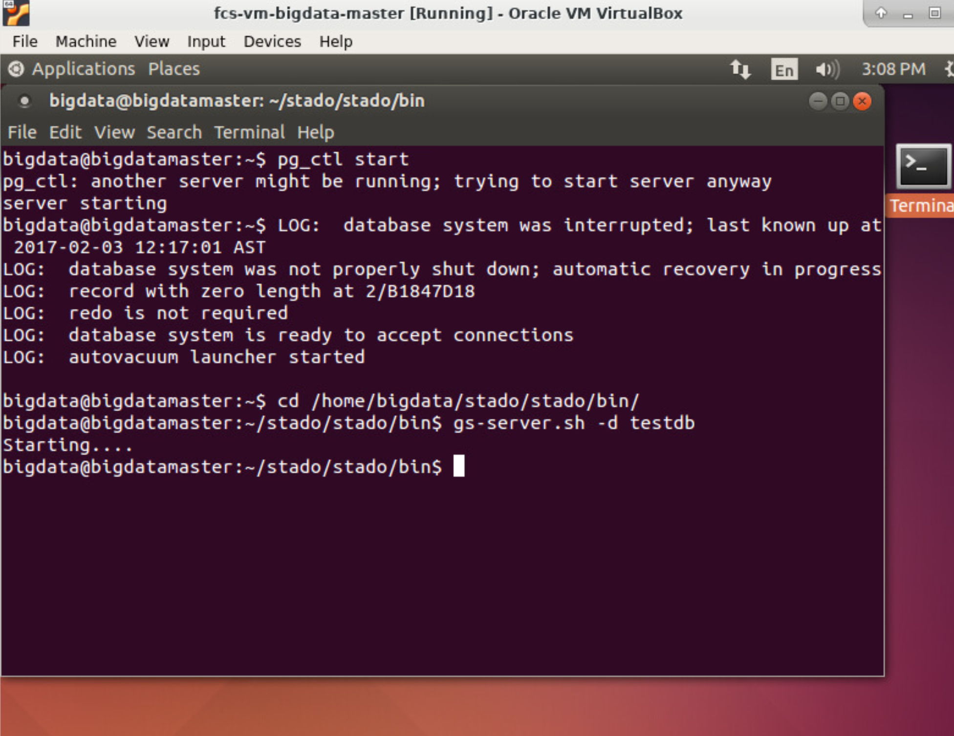

1. We will start Stado SQL client to connect to the parallel database. **$ gs-cmdline.sh -d testdb -u admin -p admin -z**

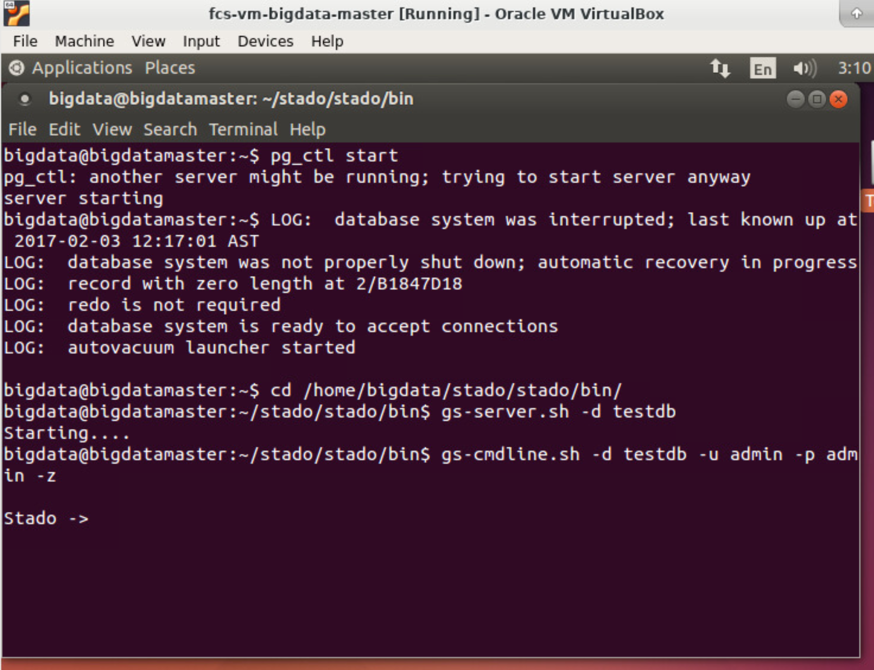

1. Then we are abale to see the tables in the database or create and insert in it.

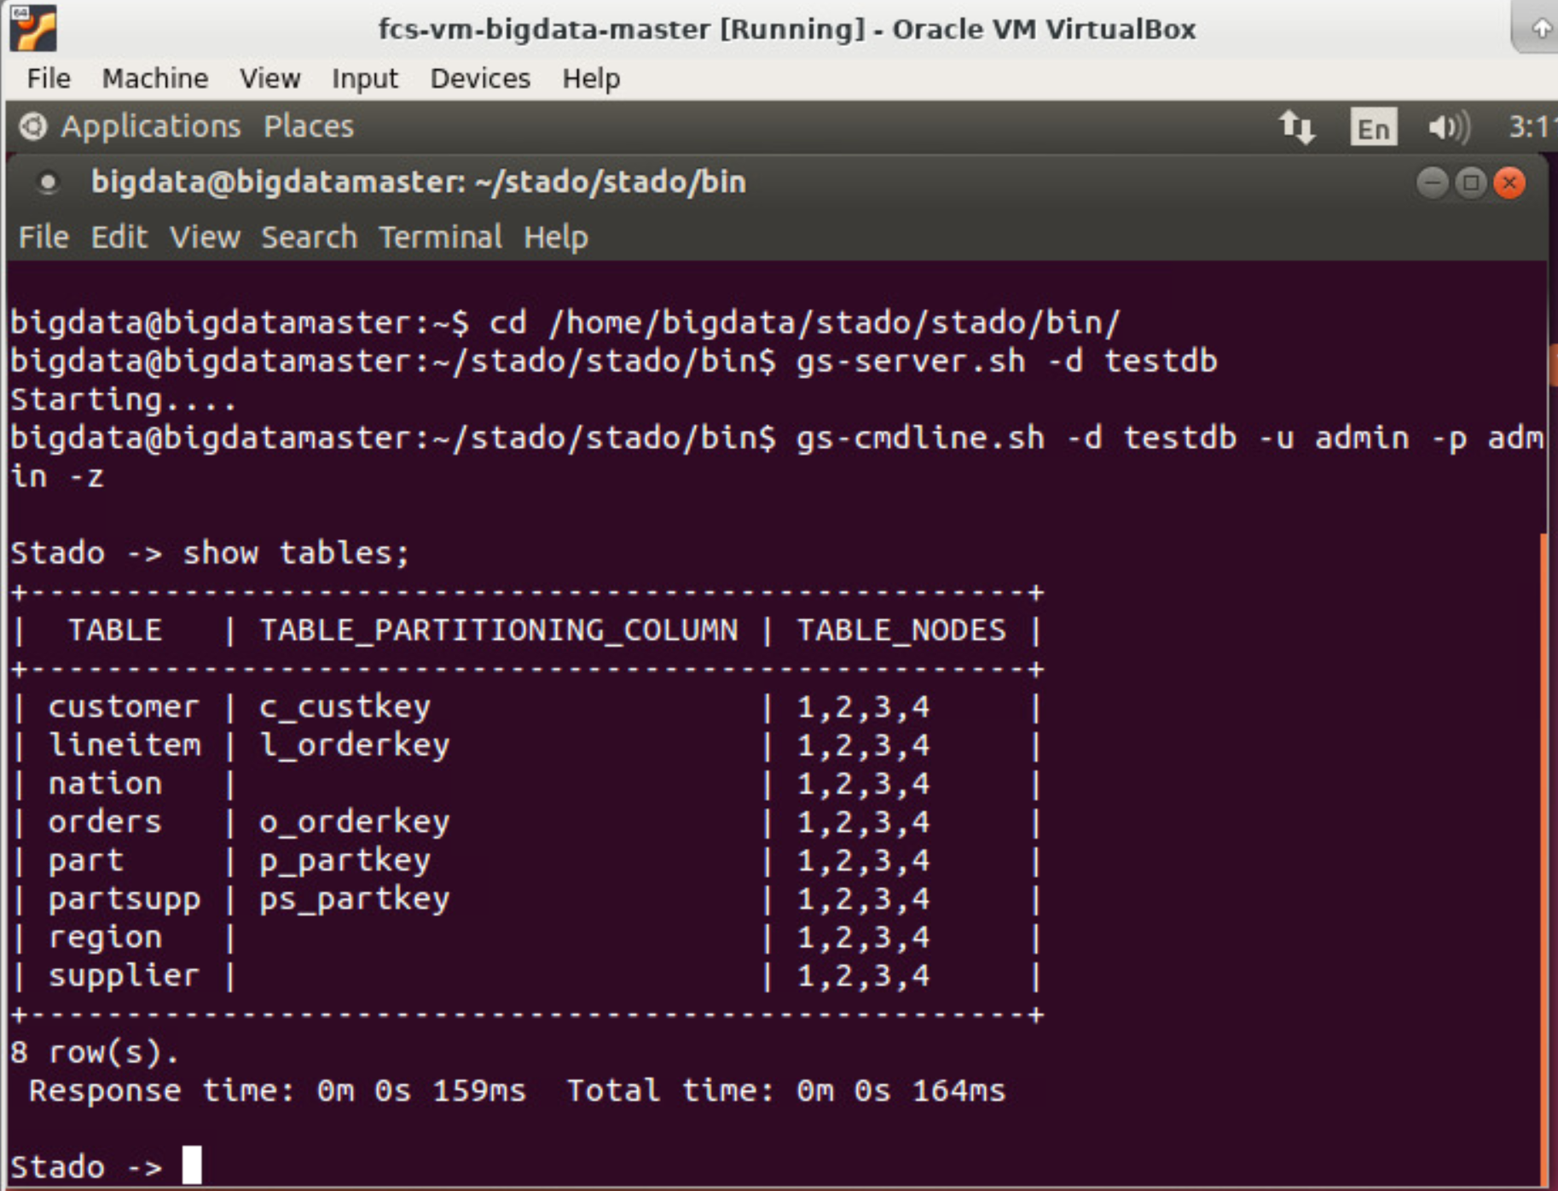

# Task 1

## 1.a Create a partitioned table partab

To Create a partitioned table named partab with 2 column including (col1, Integer) and (col2, Char) and partition key of (col1) we use the query below:

$$CREATE TABLE partab (col1 INTEGER, col2 CHAR(15)) PARTITIONING KEY col1 ON ALL;$$

And response is:

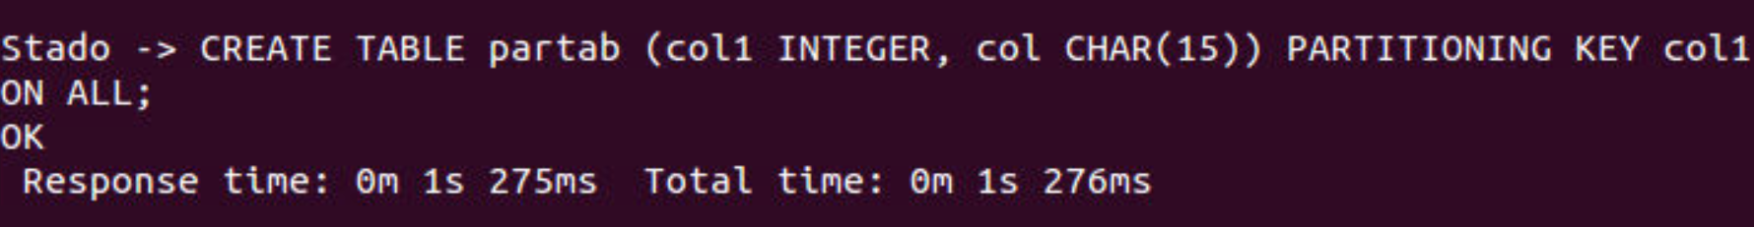

So the table is created. And Show tables here include the new table:

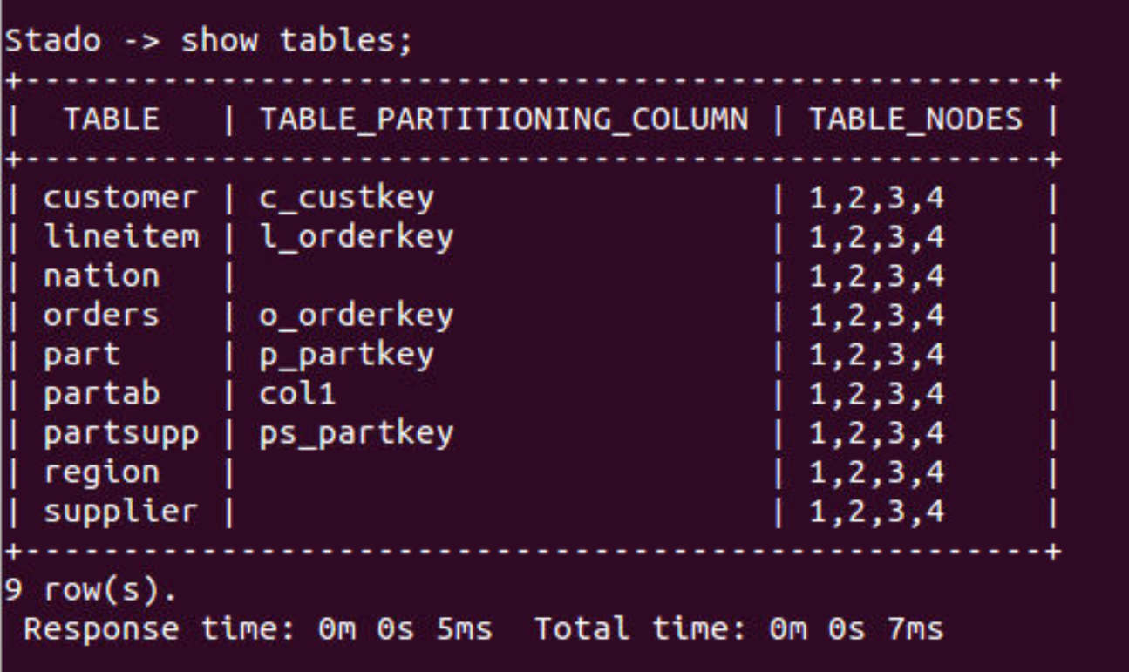

## 1.b Insert the tuples (with given values) into partab

We will Insert 6 predefined tuples into our partab table that we created before. We use the command Below:

$$INSERT INTO partab VALUES (‘2’,’I’), …$$

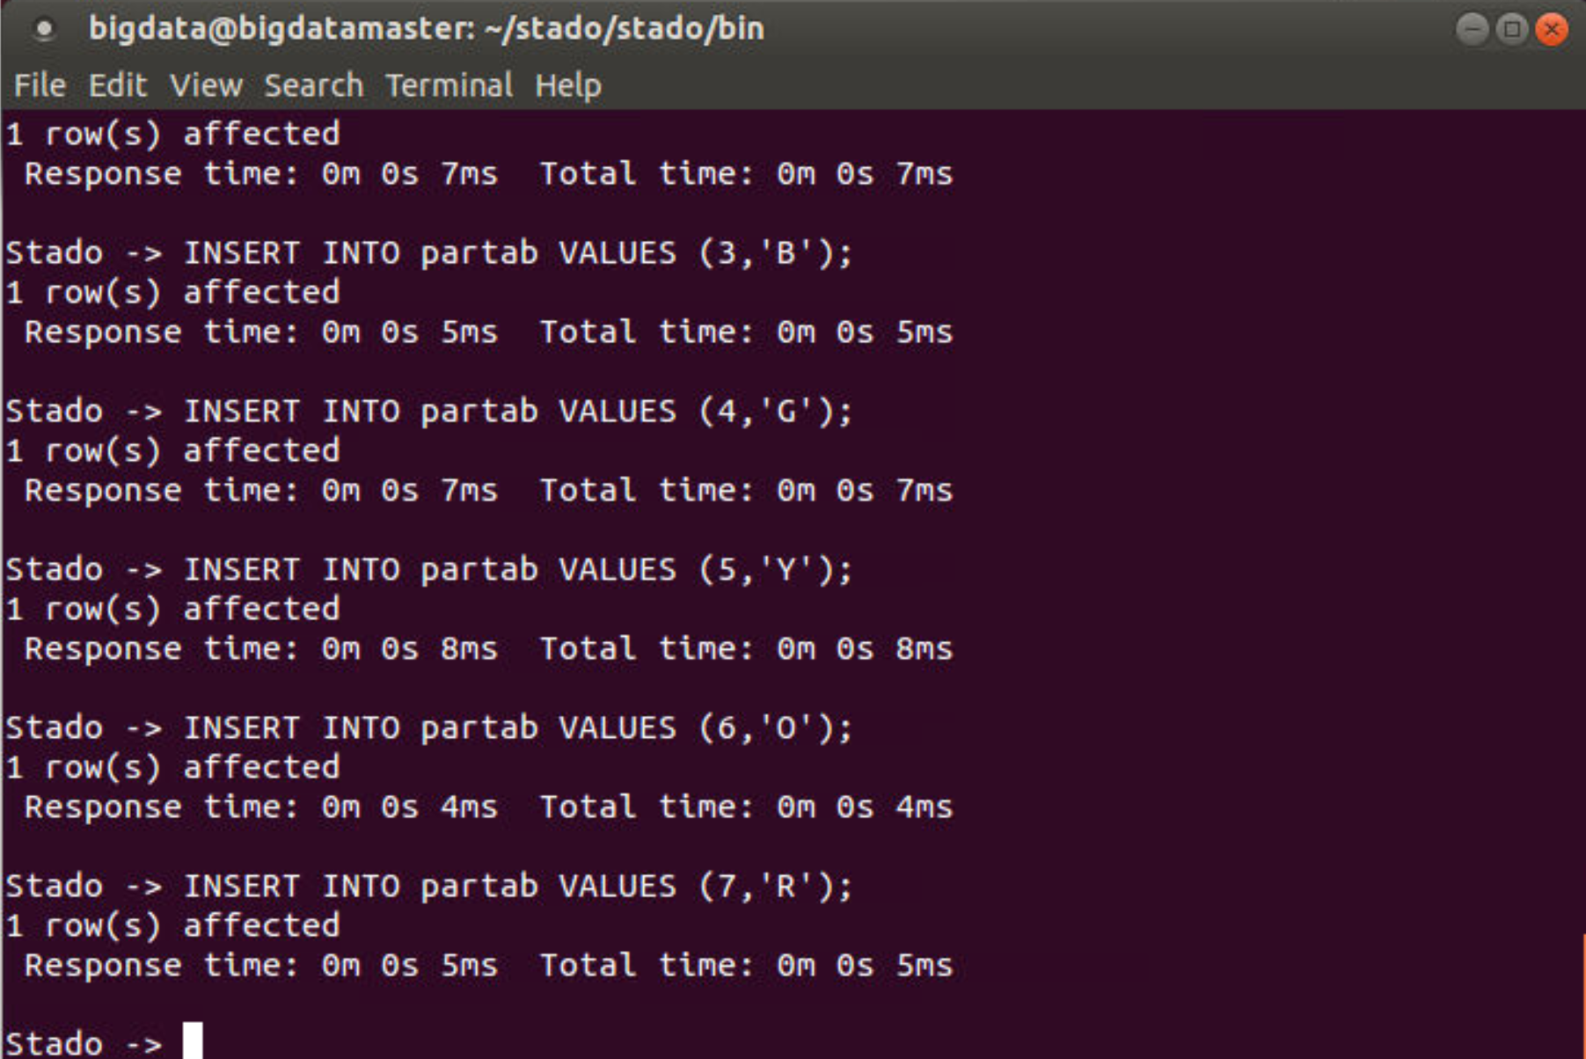

After Inserting all the tuples we can query our table and check if the tuples are in the table using the command below and see the result:

$$SELECT * FROM partab$$

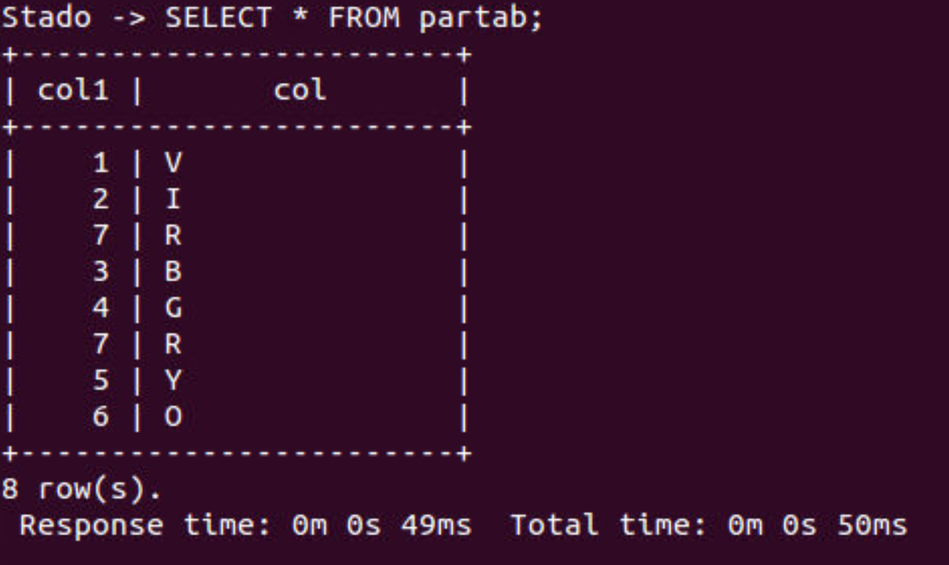

Table Actually have all the rows (7,’R’) is not displayed and it was inserted twice. So all the insertion worked perfectly fine.

## 2.a Create a replicated table reptab.

To Create a replicated table named reptab with 2 column including (fld1, Integer) and (fld2, Char(2)) we use the query below:

$$CREATE TABLE reptab (fld1 INTEGER, fld2 CHAR(2)) REPLICATED;$$

And response is:

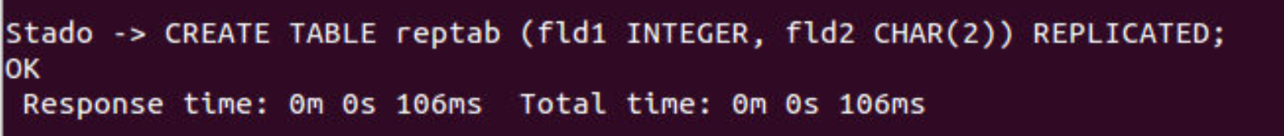

So the table is created. And Show tables here include the new table:

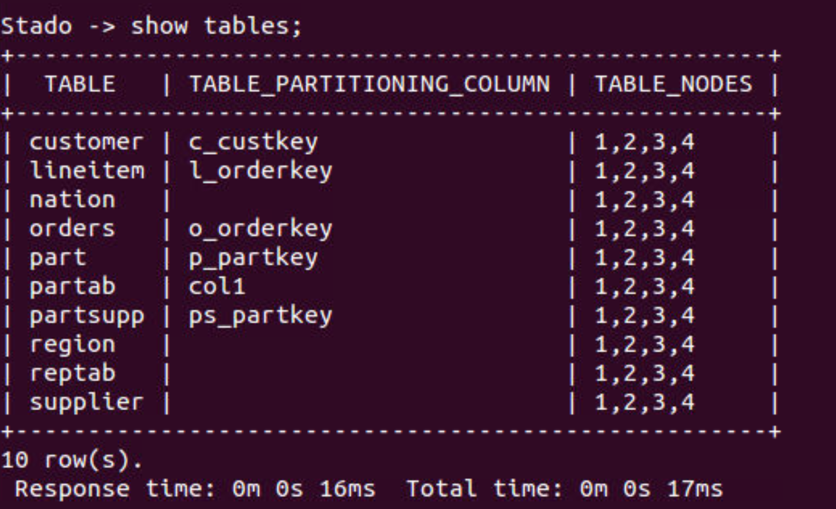

## 2.b Insert the tuples (with given values) into reptab

We will Insert 6 predefined tuples into our reptab table that we created before. We use the command Below:

$$INSERT INTO reptab VALUES (‘2’,’I’), …$$

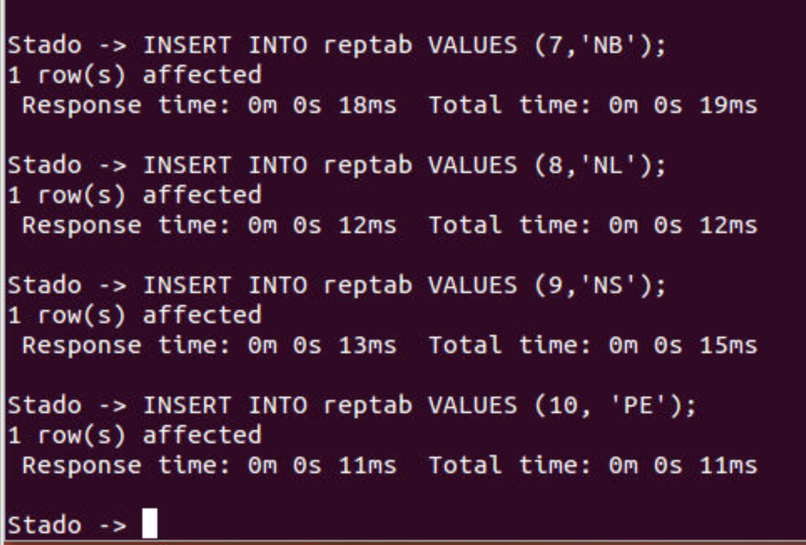

After Inserting all the tuples we can query our table and check if the tuples are in the table using the command below and see the result:

$$SELECT * FROM reptab$$

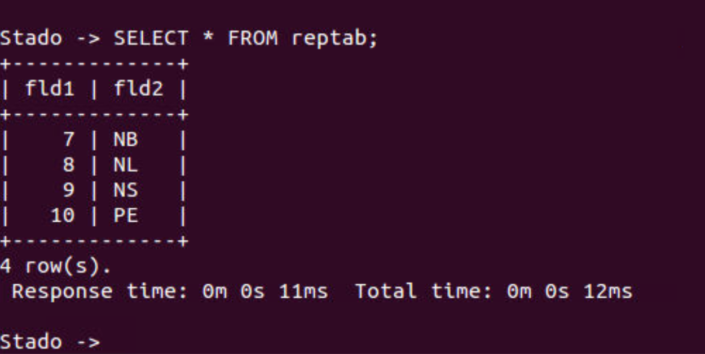

As we can see all the tuples were inserted into the reptab successfully.

## Results Only:

1. Partitioned

$$CREATE TABLE partab (col1 INTEGER, col2 CHAR) PARTITIONING KEY col1 ON ALL;$$

### Schema of your table partab (output of: show table partab)

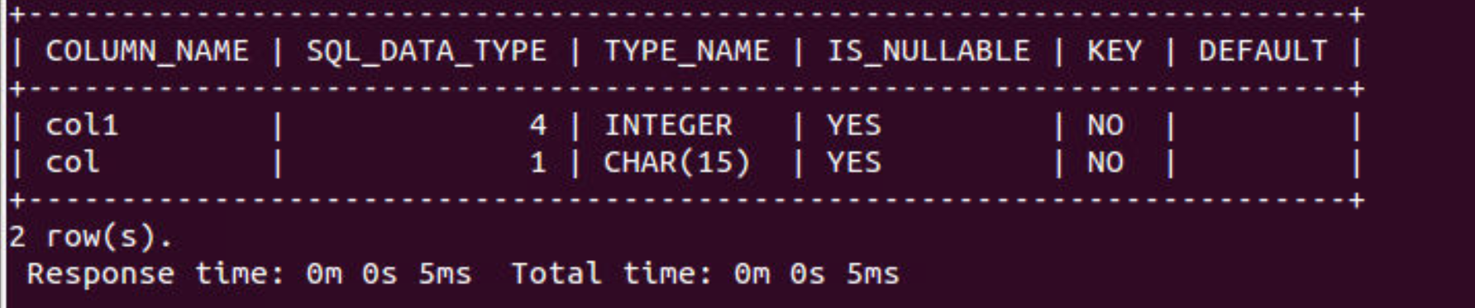

### Output of the query: SELECT * FROM partab



1. Replicated

Schema of your table reptab (output of: show table reptab)

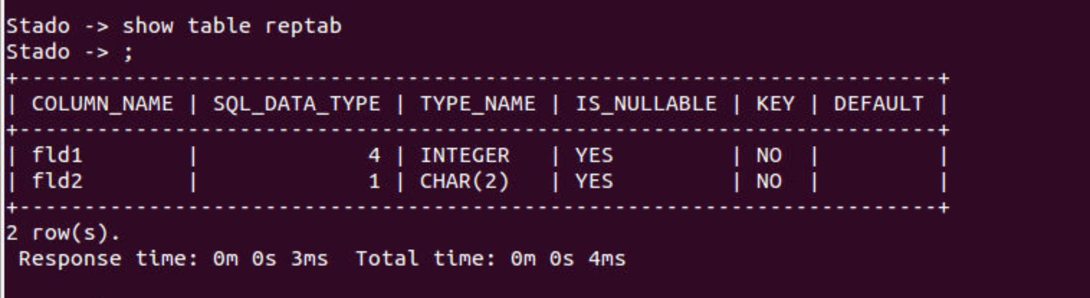

### Output of the query: SELECT * FROM reptab



# Task 2

Here we are going to run 3 queries from TPC-H benchmark and find the response time of database in 2 modes Parallel and Single. I ignored the first run of each query (cold) and made a note of the response time of 2 next query execution for both modes.

## Run 3 query on Stado as parallel database.

### Query 1:

After running 1 time (cold run) the Second result is: **Time: 13s 689ms**

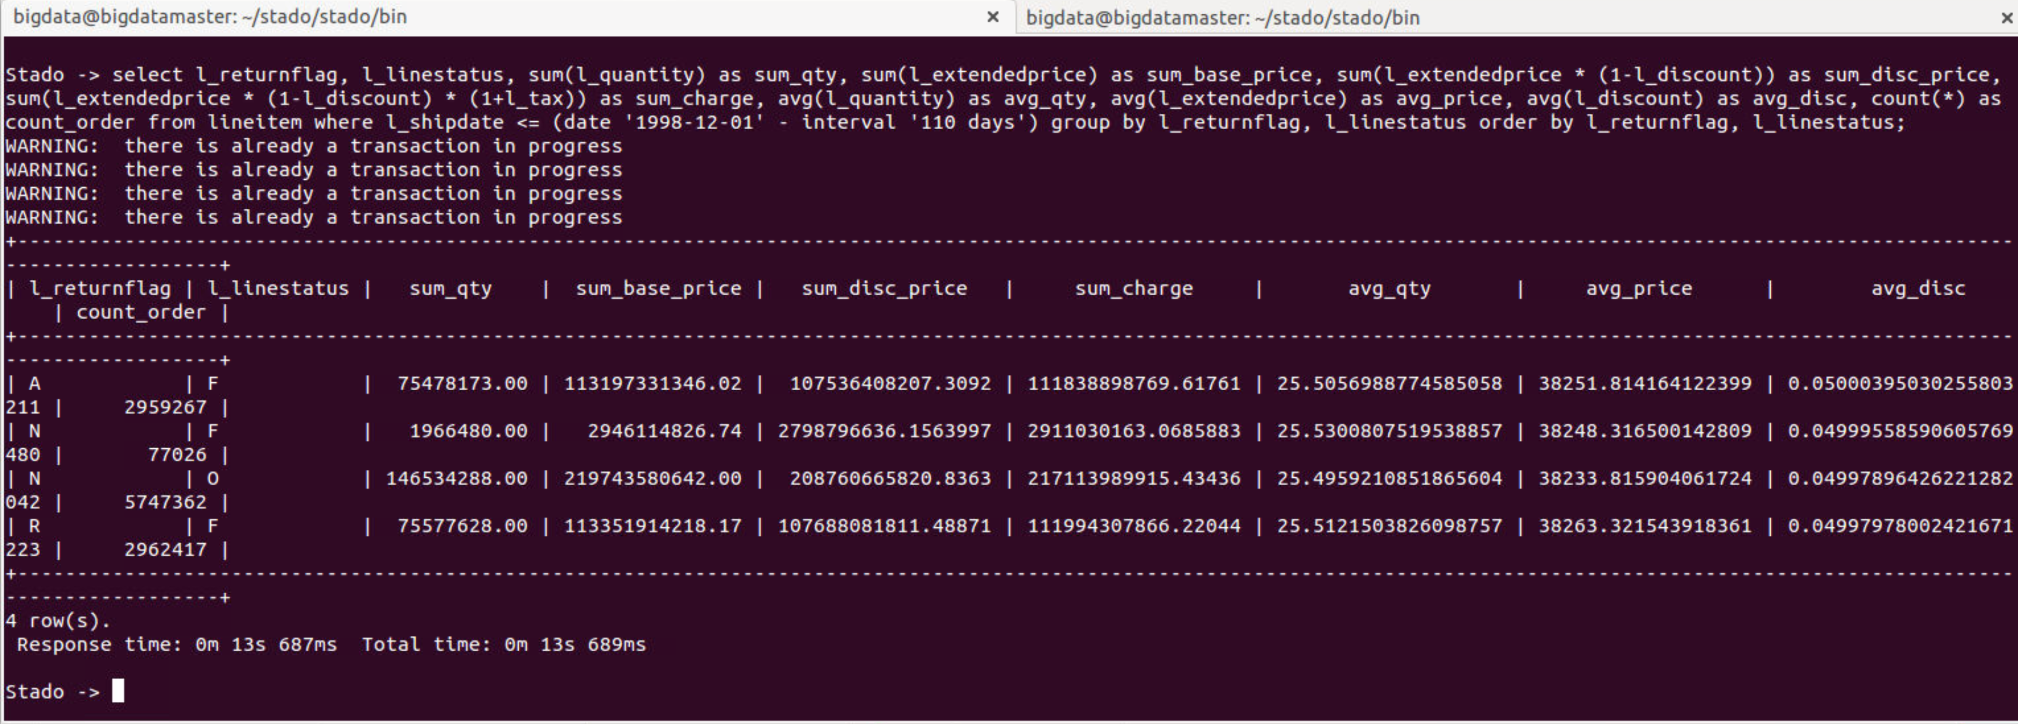

Third run is: **Time: 13s 961ms**

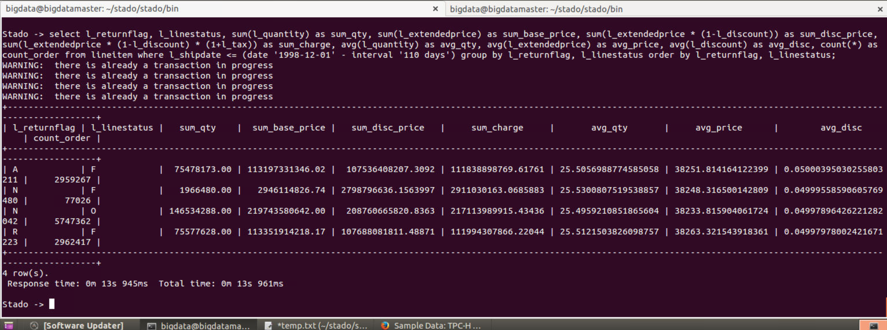

### Query 3:

After running 1 time (cold run) the Second result is: **Time: 10s 451ms**



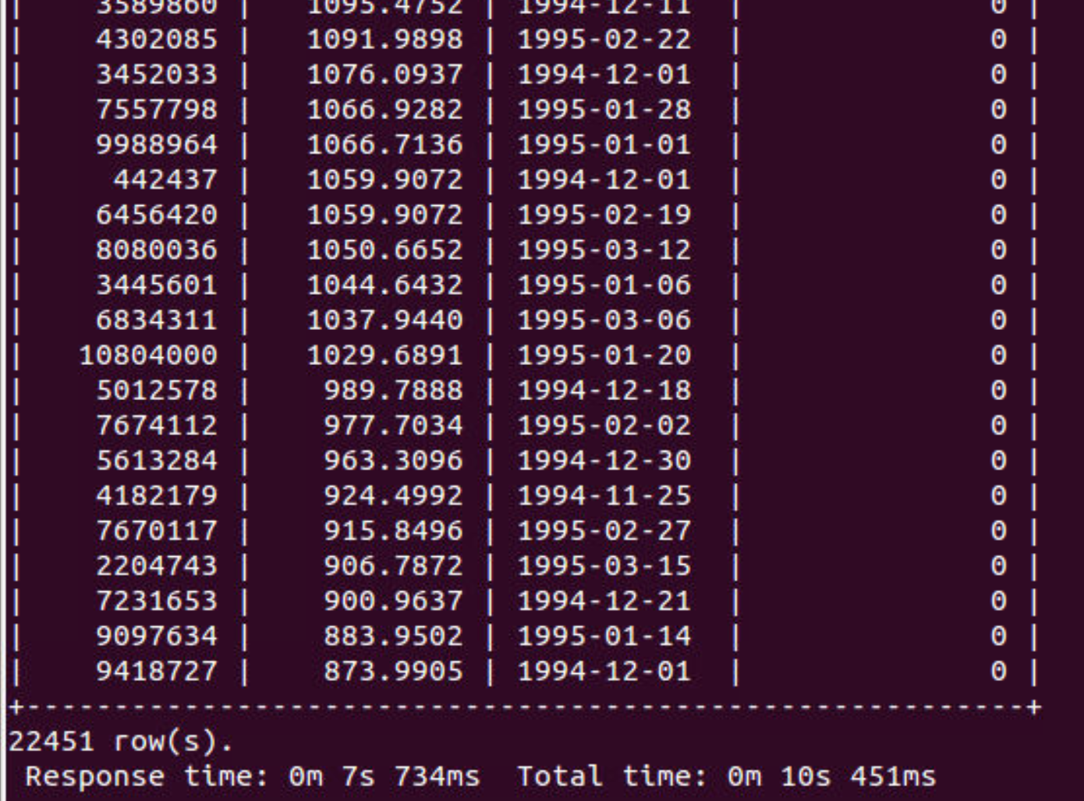

Third run is: **Time: 10s 459ms**

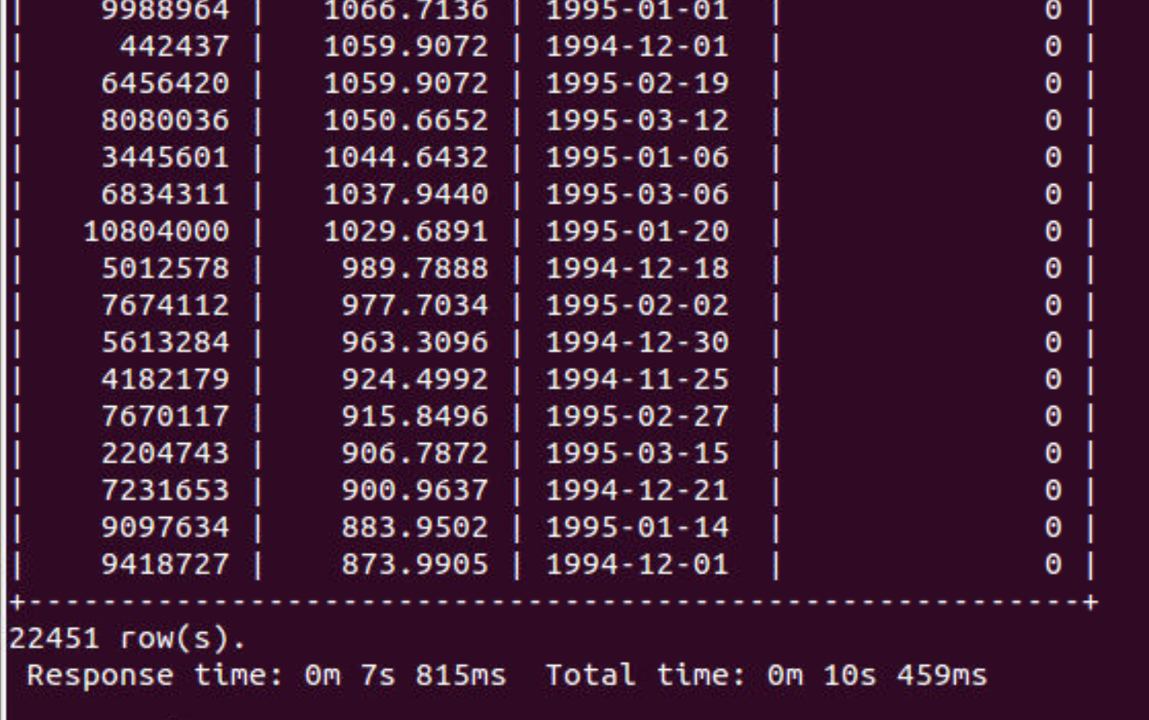

### Query 6:

After running 1 time (cold run) the Second result is: **Time: 2s 219ms**



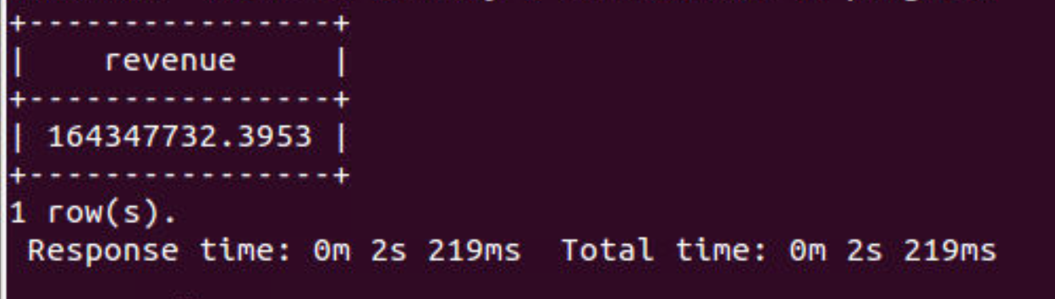

Third run is: **Time: 1s 909ms**

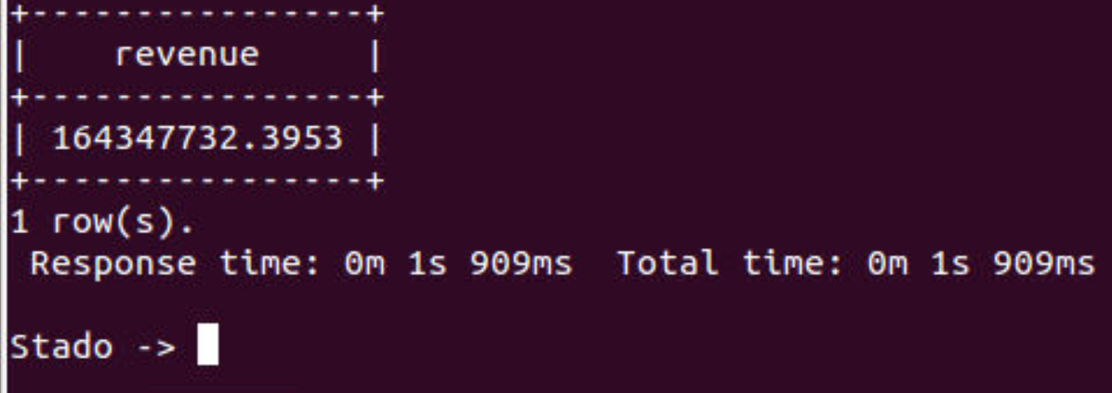

## Run 3 query on PostgreSQL as Single database.

First we stop the Stado and go to PostgreSQL command line to do the queries.

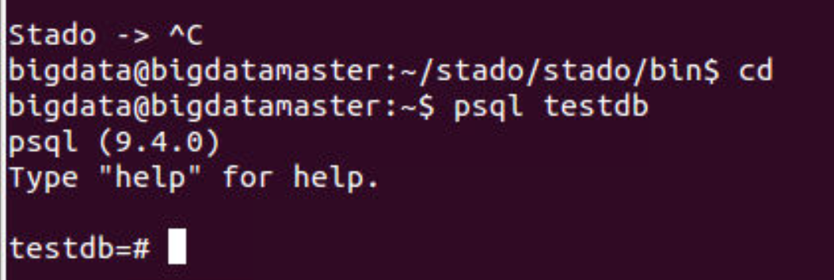

### Query 1:

After running 1 time (cold run) the Second result is: **Time: 40s 248ms**



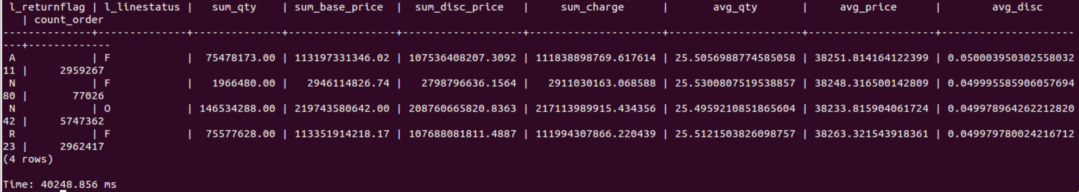

Third run is: **Time: 40s 788ms**

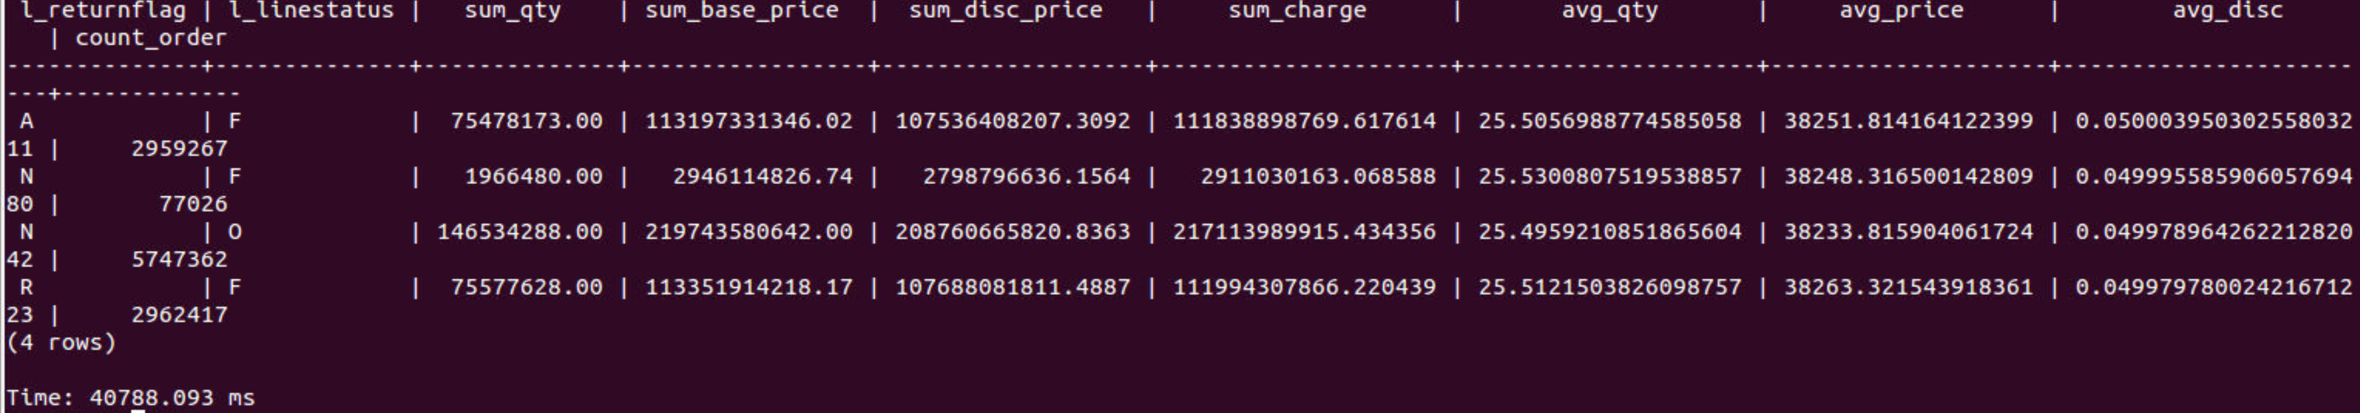

### Query 3:

After running 1 time (cold run) the Second result is: **Time: 16s 948ms**



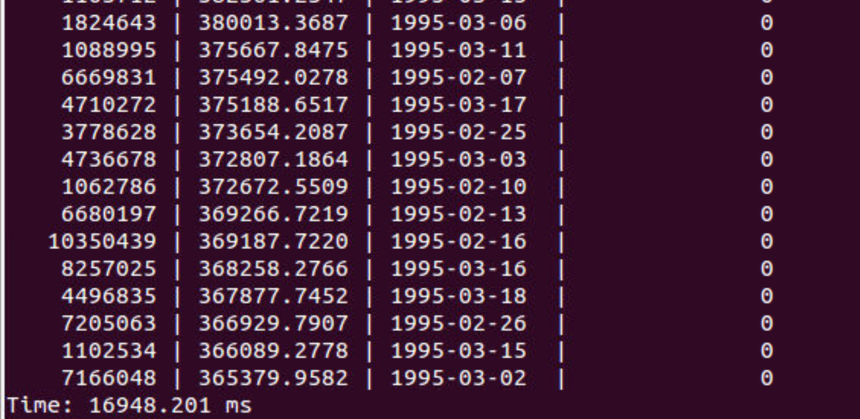

Third run is: **Time: 16s 187ms**

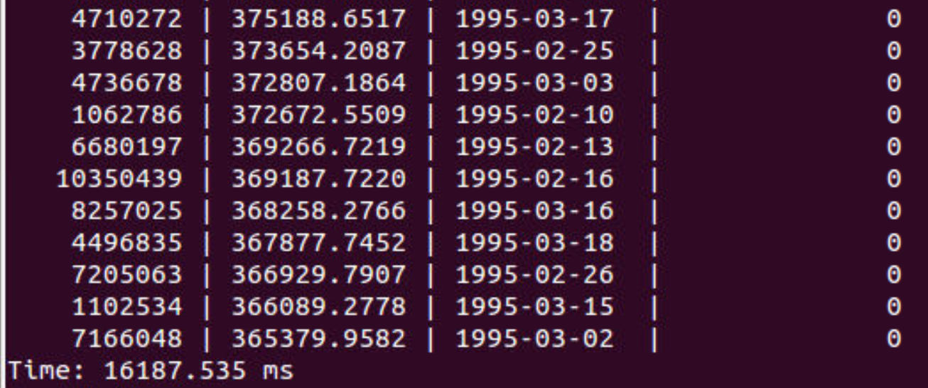

### Query 6:

After running 1 time (cold run) the Second result is: **Time: 32s 14ms**



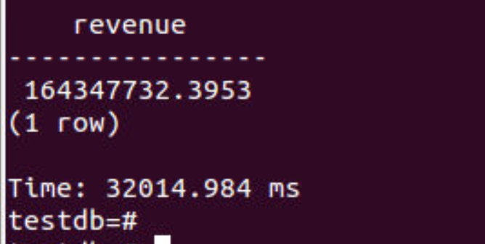

Third run is: **Time: 31s 888ms**

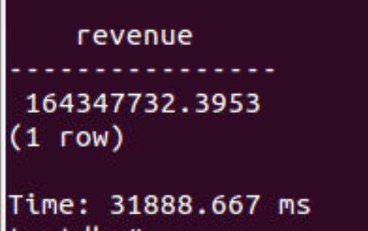

## Results Only

### Average execution time of the warm runs of Q1, Q3 and Q6 with Stado

$$Q1 \left\{\begin{aligned}warn run 1 : 13s 689ms :13689ms \\ warn run 2 : 13s 961ms :13961ms\end{aligned}\right. →Avg=13825ms$$

$$Q3 \left\{\begin{aligned}warn run 1 : 10s 451ms :10451ms \\ warn run 2 : 10s 459ms :10459ms\end{aligned}\right. →Avg=10455ms$$

$$Q6 \left\{\begin{aligned}warn run 1 : 2s 219ms :2219ms \\ warn run 2 : 1s 909ms :1909ms\end{aligned}\right. →Avg=2064ms$$

### Average execution time of the warm runs of Q1, Q3 and Q6 with Single DB

$$Q1 \left\{\begin{aligned}warn run 1 : 40s 248ms :40248ms \\ warn run 2 : 40s 788ms :40788ms\end{aligned}\right. →Avg=40518ms$$

$$Q3 \left\{\begin{aligned}warn run 1 : 16s 948ms :16948ms \\ warn run 2 : 16s 187ms :16187ms\end{aligned}\right. →Avg=16568ms$$

$$Q6 \left\{\begin{aligned}warn run 1 : 32s 14ms :32014ms \\ warn run 2 : 31s 888ms :31888ms\end{aligned}\right. →Avg=31951ms$$

### Speedup of Q1, Q3 and Q6 achieved with Stado against single instance PostgreSQL

$$Q1 Speedup= \frac{40518}{13825}=2.93$$

$$Q3 Speedup= \frac{16568}{10455}=1.584$$

$$Q6 Speedup= \frac{31951}{2064}=15.48$$